**LAB 3: Freighter Races**

Ratthamnoon Prakitpong - 63205165

Hamayun Aziz - 62064167

Arjun Vadehra - 20037164

Section A

Lab Date: February 23rd, 2018

**Summary**

This lab can be separated into roughly two sections. In the first part, we constructed a foam boat, ran it six times under different driving and cargo mass, and collected data to calculate for the drag coefficient. In the second part, we used the profile of the boat from the first part to calculate for combination of driving and cargo mass that will maximize its score, without the boat destabilizing. There were many variables considered in the calculations, such as Reynolds number, drag coefficient, and buoyancy. We concluded that our design would have had a lower drag coefficient if it had a more streamlined shape, however, this would mean that we would be able to carry a smaller load.

**Procedures**

See Mech 222 Lab manual

**Results and Calculations**

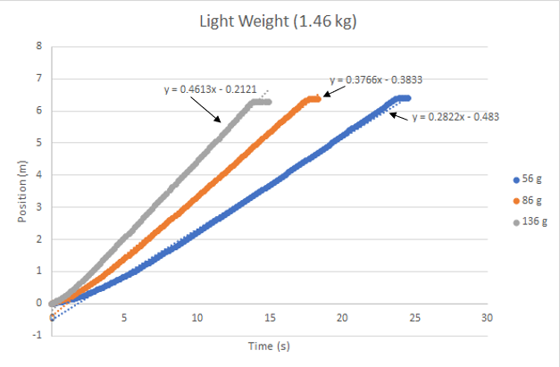

*Figure 1: Position vs Time for Light Load*

*Note: In this graph, gray corresponds to case #5, orange corresponds to case #3, and blue corresponds to case #1*

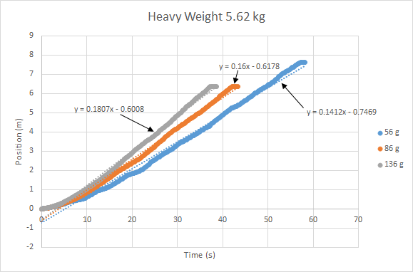

*Figure 2: Position vs Time for Heavy Load*

*Note: In this graph, gray corresponds to case #6, orange corresponds to case #4, and blue corresponds to case #2*

|  |  |  |  |  |
| --- | --- | --- | --- | --- |
| **Case number (#)** | **M drive (Kg)** | **Cargo Mass (Kg)** | **Time taken (s)** | **Calculated score** |
| 1 | 0.056 | 1.46 | 24.5 | 1.553 |
| 2 | 0.056 | 5.62 | 58.901 | 9.575 |
| 3 | 0.086 | 1.46 | 18.3 | 1.354 |
| 4 | 0.086 | 5.62 | 43.3 | 8.482 |
| 5 | 0.136 | 1.46 | 14.9 | 1.051 |
| 6 | 0.136 | 5.62 | 38.7 | 6.000 |
| 7 (competition) | 0.056 | 2.13 | 35.3 | 2.295 |

*Table 1: Scoring using measured values*

*Note: Case #7 is competition case, where driving and cargo mass were calculated to maximize the score*

|  |  |
| --- | --- |
| Driving mass and mass carried (kg) | Measured velocity (m/s) |
| 0.056kg - 1.46 | V = 0.2822 |
| 0.086 - 1.46 | V = 0.3766 |
| 0.136 - 1.46 | V = 0.4613 |
| 0.056kg - 5.62 | V = 0.1412 |
| 0.086kg - 5.62 | V = 0.1600 |
| 0.136kg - 5.62 | V = 0.1807 |

*Table 2: Measured velocities*

|  |  |  |
| --- | --- | --- |
| Equation 1 | Scoring formula |  |
| Equation 2 | Prediction error | (ScorePredicted - Score)/Score x 100% |
|  | Pulley mass | 0.036 kg |

*Table 3: Miscellaneous equations and constants*

|  |  |
| --- | --- |
| *Figure 3: Case #1* | *Figure 4: Case #2* |
| *Figure 5: Case #3* | *Figure 6: Case #4* |
| *Figure 7: Case #5* | *Figure 8: Case #6* |

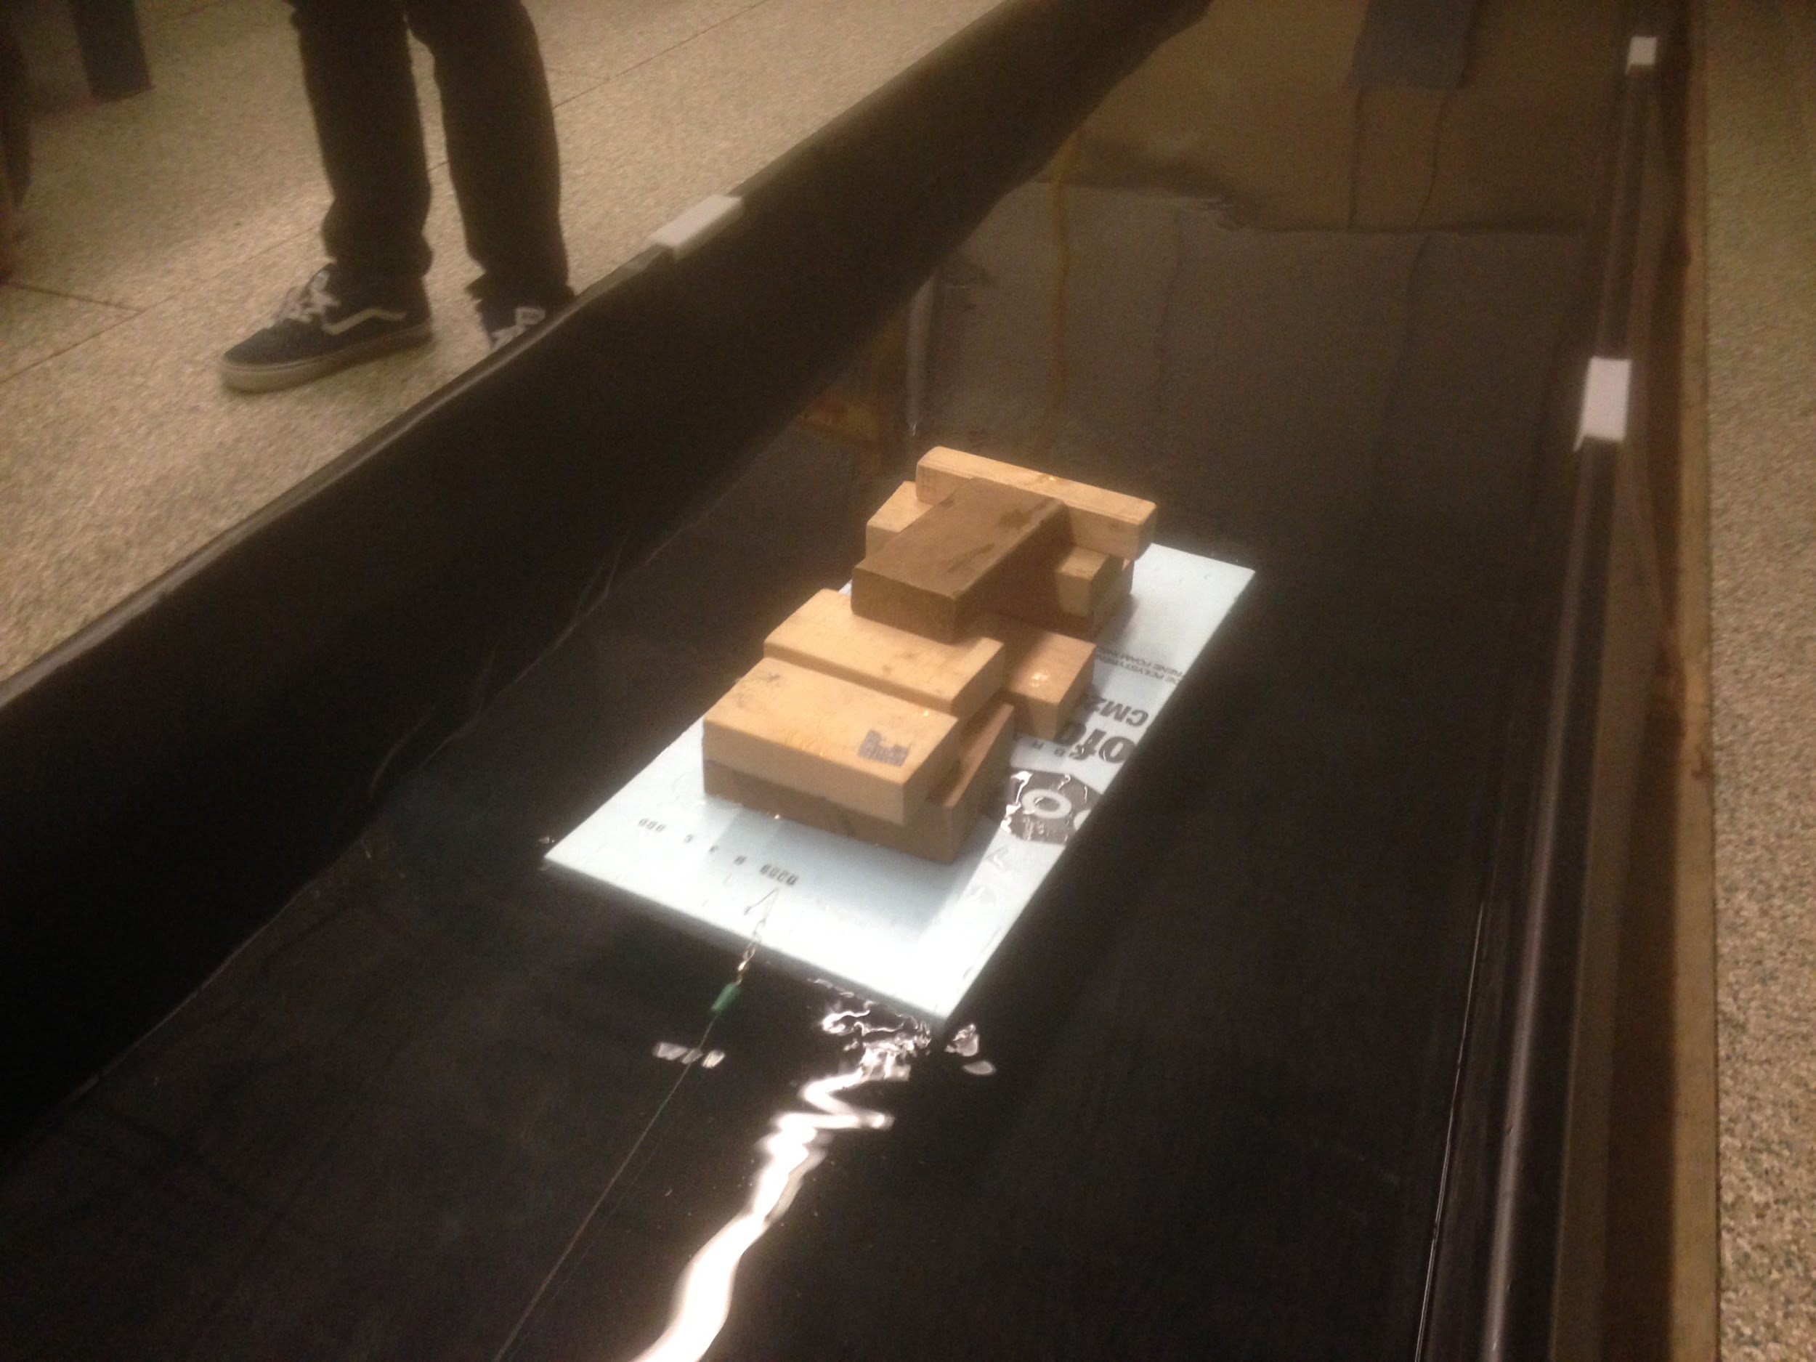

*Figure 9: Case #7*

|  |  |  |  |  |  |  |
| --- | --- | --- | --- | --- | --- | --- |
|  | Driving Mass (kg) | Driving Force (N) | Velocity (m/s) | Density (kg/m^3) | Wetted Area (m^2) | Drag Coefficient |
| Light Load (1.46 kg) | 0.056 | 0.183 | 0.282 | 1000.000 | 0.195 | 0.024 |
| 0.086 | 0.281 | 0.377 | 1000.000 | 0.195 | 0.020 |
| 0.136 | 0.445 | 0.461 | 1000.000 | 0.195 | 0.021 |
| Heavy Load (5.62 kg) | 0.056 | 0.183 | 0.141 | 1000.000 | 0.236 | 0.078 |
| 0.086 | 0.281 | 0.160 | 1000.000 | 0.236 | 0.093 |
| 0.136 | 0.445 | 0.181 | 1000.000 | 0.236 | 0.115 |

*Table 4: Drag Coefficient Calculations*

*Note: Sample Calculations can be found in the Appendix*

Drag Coefficient =

Where Fd is the driving mass, p is the density , v is velocity and S is the wetted area.

According to the Drag Coefficient equation, drag coefficient increases with:

1. Increase in Driving Mass since this causes the Fd to increase
2. Decrease with the increases the load on the boat since this causes the wetted area to increase
3. Decrease in the velocity of the boat since its inversely proportional to drag coefficient

The following observations can be made from Table 4:

1. The Drag coefficient does increase with the increase in the driving mass as can be seen in the drag coefficients for the heavy load of 5.62 kg
2. The load on the boat seems to have a minimal impact on the drag coefficient. The load on the boat determines the wetted surface area as can be seen in Appendix B. There is a very small difference between the wetted surface area between the two load conditions ( 1.46 and 5.62 kg) so it doesn’t impact the drag coefficient value as much.
3. The velocity of the different cases of the heavy loads are very similar, so it doesn’t affect the drag coefficient of the heavy load a lot as would be expected since velocity is squared. Therefore, the driving mass plays a greater role in determining the drag coefficient of the boat. Hence we see a general increase in the drag coefficients with the increase in the driving loads rather than a general decrease(due to velocity)
4. The drag coefficient generally decreases with the increase in the velocity of the light load values. The driving mass doesn’t have a big impact on the drag coefficient value as compared to the velocity. Velocity has a bigger impact since velocity is squared in the denominator of the equation. Hence we see the general decrease in the drag coefficient for the light load.

**Discussion/Required Content**

1. **A full-page graph in which you overlay your 3 experimental runs with high cargo load (indicate the total cargo weight).**

Please refer to Figure 2 on page 4.

1. **On a second full-page graph, overlay your 3 experimental runs with low cargo load (indicate the total cargo weight).**

Please refer to Figure 1 on page 3.

1. **On a separate page, compile the 6 boat photos with clear labels corresponding to the curves on the previous graphs.**

Please refer to Figure 3-9 on page 5.

1. **Determine the “overall drag coefficient” (defined as) for your boat using the steady-state portion of the lab data. Compare your six trials and comment on the results.**

Please refer to Table 4 and the discussion on page 6.

1. **Determine your Prediction Error (Equation 12) and comment on the results. (If there is a significant discrepancy, describe what you believe are the primary causes.)**

Score Predicted(mDrive = 0.056 kg, m Cargo = 2.13 kg) = 1.8574 (Appendix A)

Score = (Equation 1)

= (2.13 kg)2 / (0.056 kg * 35.3 s)

= 2.295 (Table 1)

Prediction error = (ScorePredicted-Score)/Score * 100% (Equation 2)

= (1.8574 - 2.295)/2.295 * 100%

= -19%

The prediction was 19% under the actual score. This is a result of two corresponding factors. The first factor is that the team could not find the blocks of wood that corresponds with the calculated cargo mass, which results in using more cargo mass than calculated. Since the score is calculated with a heavier emphasis on cargo mass (W2), a small change in cargo mass results in a large change in score.

1. **Knowing what you know now, comment on how you would have designed your foam boat differently if you were to repeat the lab.**

Knowing that the total drag force is comprised of skin friction drag, form drag and wave drag, changes in specific dimensions could have reduced total drag significantly. In particular, reducing the width of the boat and streamlining the frontal face would have resulted in reductions to both pressure based (delayed separation) and frictional drag. Reducing the length of the boat would have decreased the calculated Reynolds number thereby increasing the likelihood of laminar flow however the loss in cargo capacity must also be considered.

**Appendix A**

*Note: This code works in two parts. Given an input of a driving mass in grams (m_drive_grams), and constant dimensions of a rectangular boat (w_foam, l_foam, h_foam) and how much the desired boat sinking (h_water), the function varieddrive outputs an array of the corresponding cargo mass, driving mass, velocity, and score (B = [m_cargo; m_drive; velocity; score]). The function Prelab then calls on varieddrive, and gives it three different driving masses from the choices available in the lab. The function Prelab outputs three arrays corresponding to the three outputs from varieddrive.*

function [A, B, C] = Prelab

A = varieddrive(56);

B = varieddrive(86);

C = varieddrive(136);

end

function B = varieddrive(m_drive_grams)

m_drive = m_drive_grams/1000;

w_foam = 30/100;

l_foam = 60/100;

h_foam= 2.5/100;

h_water = 1.25/100;

rho_water=1000;

rho_foam = 26.67;

gravity = 9.81;

m_foam= w_foam*l_foam*h_foam*rho_foam;

m_cargo=(rho_water*gravity*w_foam*l_foam*h_water- m_foam*gravity)/9.81;

m_total=m_foam+m_cargo;

F_drive=m_drive*gravity/3;

velocity=0;

pastvelocity =10;

timestep=0.001;

totaltime=0;

i=1;

a= 1;

Area_wet = h_water*2*(w_foam+l_foam);

while pastvelocity ~= velocity

F_s = 1/2*rho_water*velocity^2*Area_wet*1.327/Fsqrt(velocity*l_foam/(1.15*10^(-6)));

if velocity ==0

F_s =0;

end

F_f = 1/2*rho_water*velocity^2*w_foam*h_water;

C_w=60*(velocity/sqrt(gravity*l_foam))^4;

F_w=1/2*rho_water*velocity^2*Area_wet*C_w;

a = (F_drive -(F_s +F_f+F_w))/(m_total);

pastvelocity = velocity;

velocity = velocity+ a*timestep;

totaltime = totaltime + timestep

end

score = (m_total^2)/(m_drive*totaltime);

B = [m_cargo; m_drive; velocity; score];

end

**Appendix B**

Drag Coefficient Calculations

*Sample calculation for Light Load and 0.056 kg as driving mass*

Driving Mass = (0.056/3 ) * 9.81 = 0.183 N

Height the boat sinks = = = 0.00811 m

Wetted Area, S = (0.6*0.3) + 2(0.3 * 0.00811) + 2(0.6*0.00811) = 0.1945 m^2

Drag Coefficient = = = 0.024